Setting Up Hyperterminal

First plug in your Arduino, and wait for your PC to detect it.

The first time you run Hyperterminal, it will ask you if you want to set Hyperterminal to be your default terminal program. Either click “Yes”, or check the “Don’t ask me this question again” checkbox and click “No”.

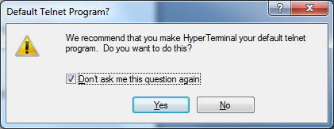

Hyperterminal may also ask you some setup questions about your region, etc. Click Cancel to get rid of that dialog box. You will then be given “New Connection” dialog box:

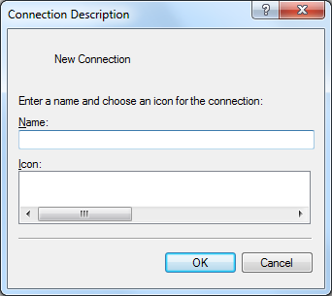

Enter CG2271 into Name, and click OK. You will now be able to setup the connection:

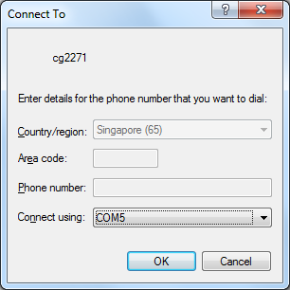

Click on the “Connect using” drop-box and choose the COM port that your Arduino is connected to. Here it is COM5. Click OK. You will get a Properties box.

Configure as shown below. MAKE SURE THAT FLOW CONTROL IS SET TO NONE!

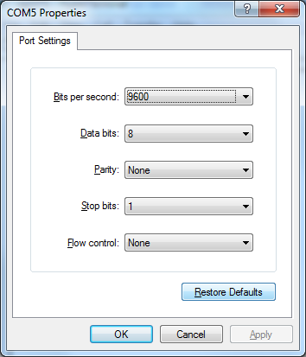

Click “Apply”. In summary you should have:

Bits per second: 9600

Data bits: 8

Parity: None

Stop bits: 1

Flow control: None

Now click OK. The Hyperterminal screen will appear (probably without the “Hello World” you see here):

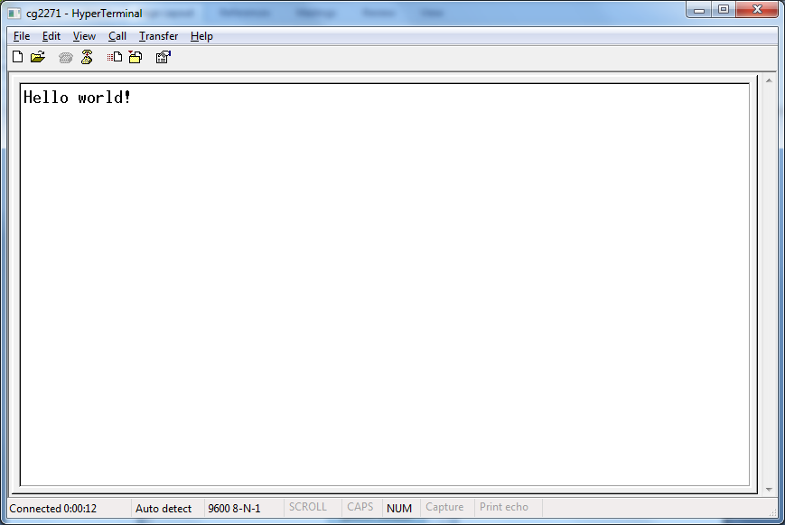

The 3rd and 4th icons at the top (circled) are for you to connect and disconnect to the Arduino.

Important: Whenever you want to flash a new program onto the Arduino, disconnect Hyperterminal first (4th icon). After flashing click on the 3rd icon to reconnect.

When you exit, save the cg2271 profile. The next time you start hyperterminal, you can skip the setup (click Cancel), then use File->Open to open the CG2271 connection.